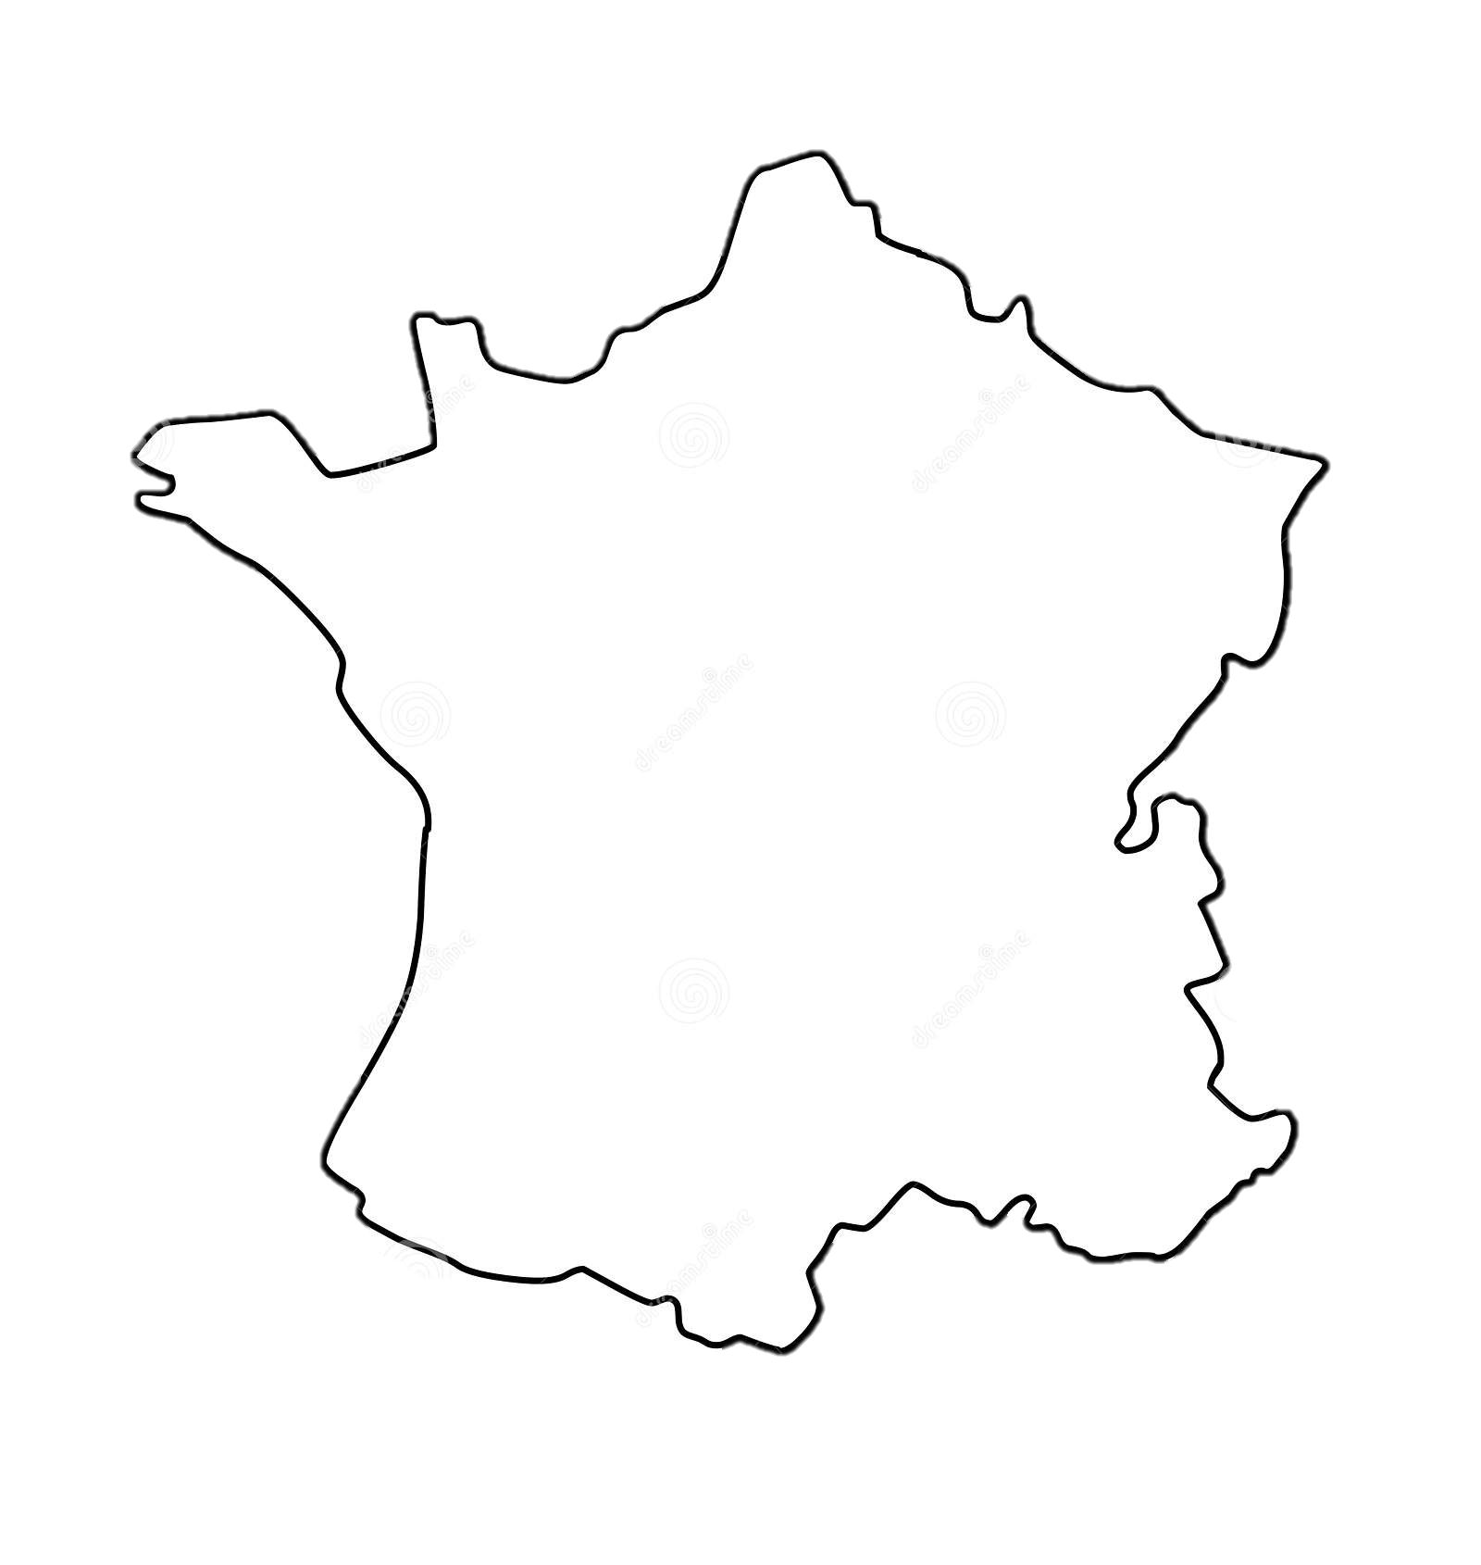



£89 per student

French GCSE Revision Days

Group Revision Sessions
10am - 3pm
2 x 2-hour sessions with a break for a traditional French lunch.
Sessions include tailored grammar consolidation, worksheets comprising reading comprehensions and translations, and listening comprehension practice.

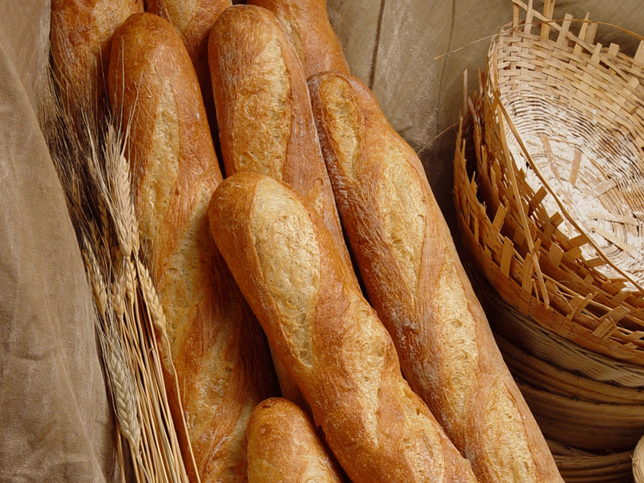

This Photo by Unknown Author is licensed under CC BY-SA
This Photo by Unknown Author is licensed under CC BY

Please contact The Language Cabin for available dates.
Places are limited and cost £89 per person including lunch, to be paid in full at the time of booking. Please email justine@thelanguagecabin.co.uk to book, confirming any dietary requirements.

Sessions will take place in Harpenden, subject to the current COVID-19 Government guidelines.
If sessions are cancelled due to COVID restrictions, students can rebook or request a full refund.

