





**£89 per student**

**German GCSE Revision Days**

## **Group Revision Sessions**

**10am - 3pm**

**2 x 2-hour sessions with a break for a traditional German lunch.**

**Sessions include tailored grammar consolidation, worksheets comprising reading comprehensions and translations, and listening comprehension practice.**

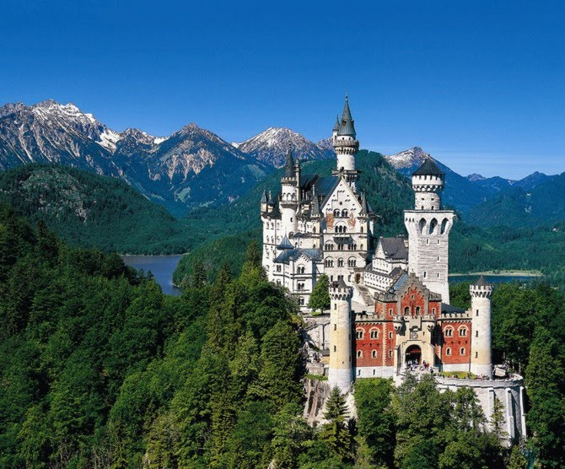

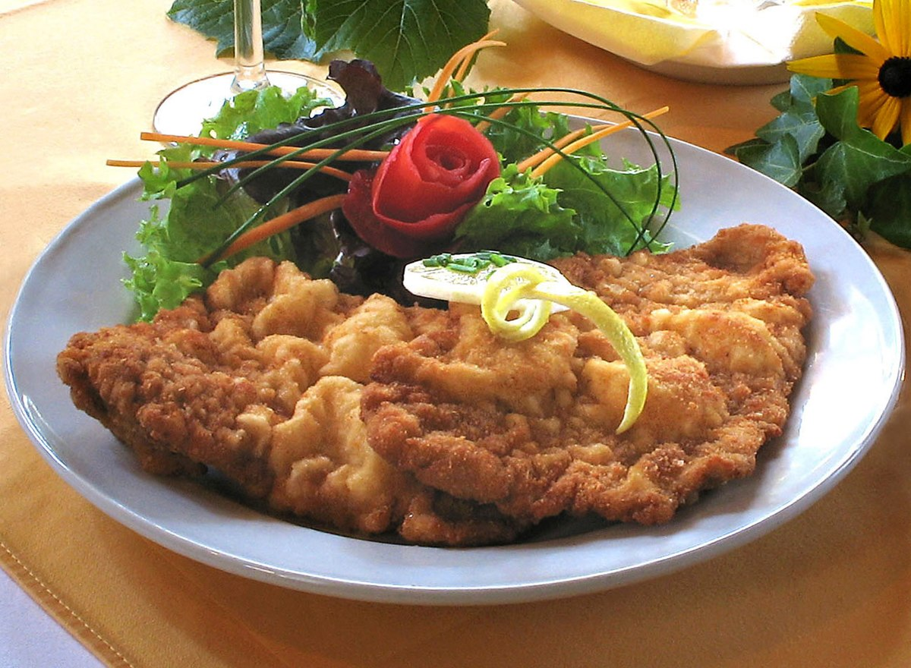

[This Photo](https://en.wikipedia.org/wiki/Wiener_schnitzel) by Unknown Author is licensed under [CC BY-SA](https://creativecommons.org/licenses/by-sa/3.0/)

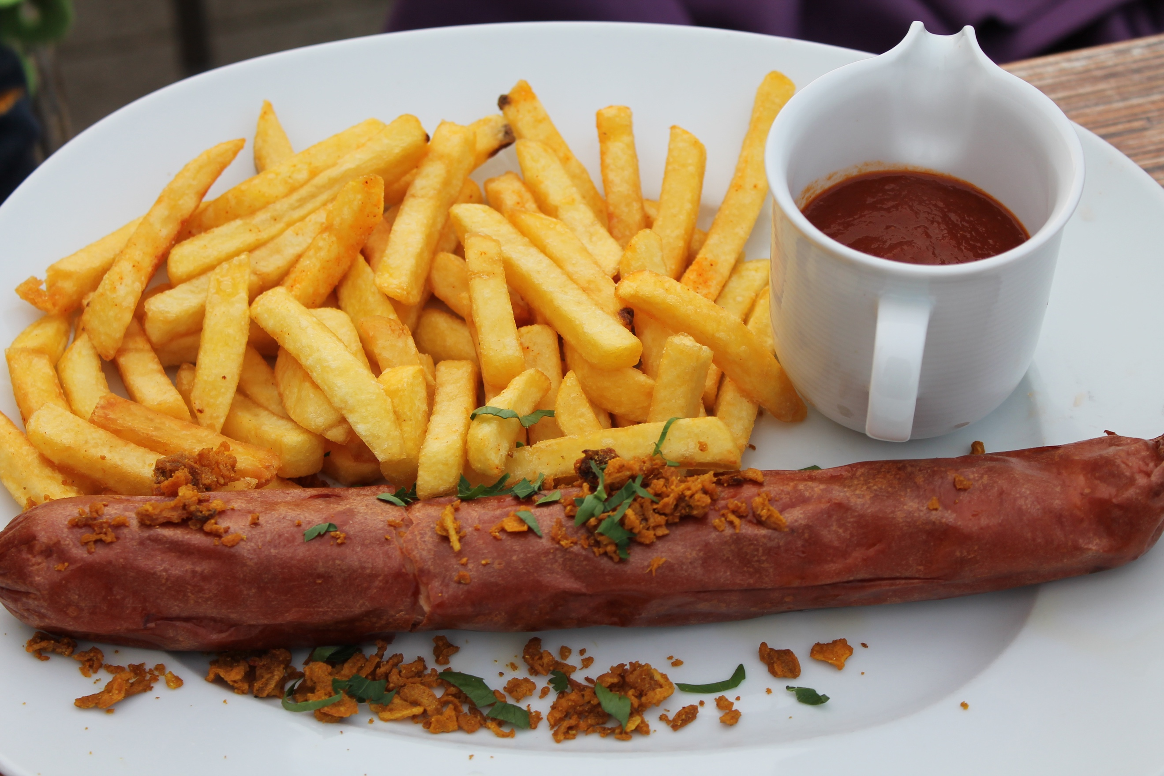

[This Photo](https://moelfabansuppers.com/tag/north-german-food/) by Unknown Author is licensed under [CC BY-NC-ND](https://creativecommons.org/licenses/by-nc-nd/3.0/)

**Please contact The Language Cabin for available dates.**

**Places are limited and cost £89 per person including lunch, to be paid in full at the time of booking. Please email justine@thelanguagecabin.co.uk to book, confirming any dietary requirements.**

**Sessions will take place in Harpenden, subject to the current COVID-19 Government guidelines.**

**If sessions are cancelled due to COVID restrictions, students can rebook or request a full refund.**